Reflections of COVID Pandemic in Oxfordshire

Director of Public Health Annual Report – 2021/22 (Technical Report)

Ansaf Azhar

Foreword

In June 2020, I launched my first director of public health annual report highlighting the major health inequalities hidden within Oxfordshire. The COVID pandemic, demonstrated this deep inequality and further exacerbated the challenges faced by our most vulnerable communities. I set out to write my second annual report for year 2021/22, which was meant to capture the reflections of COVID pandemic at that time. However, I did not publish this annual report due to pressures we faced as a system in managing COVID pandemic and its emerging variants of concern.

After successfully publishing my annual report for year 2022/23 on “Healthy weight, healthy communities, healthy lives” I have now revisited my unpublished annual report written during the pandemic. I now feel there is real value in publishing this annual report – “Reflections of COVID pandemic” as a technical report. The report aims to capture the state during this time and highlight some key issues we faced as a system as well as some of the fantastic initiatives we managed to do during this unprecedented time. It doesn’t form any recommendations but simply attempts to reflect and capture the time period.

Therefore, I now publish the technical Director of Public Health Annual Report for year 2021/22 retrospectively as it was written during the pandemic. I hope you are able to relate to this and gain useful insights and reflections.

1. Background
Where have we come from?

Last year’s Director of Public Health Annual Report highlighted Oxfordshire’s hidden inequalities.

Oxfordshire is largely a prosperous and healthy place to live. Compared to much of England, Oxfordshire’s residents can expect to live a relatively long and healthy life, there is little unemployment, children do well at school, and there are low levels of crime.

But this picture hides those areas of the county that have been left behind. The 2020 Annual Report focused on 10 wards – 10 areas of Oxfordshire that are among the most deprived in England. The gap in health and opportunity between these wards and the rest of the county was stark and getting worse.

The 2020 Report set out the importance of inclusive growth – ensuring that the benefits of economic development, new housing, cleaner air, and healthy places are shared more fairly across the county. It highlighted the importance of working with local communities to understand where investment is needed and to identify what will make the biggest difference to people’s lives.

What happened in 2020?

As a first step to understand the differences in health and opportunities across Oxfordshire, the County Council Public Health Team started to create new Ward Profiles. These not only provide granular detail on the health needs of Oxfordshire’s wards, but include community voices about what matters, the profiles map local assets, and provide a route for empowering local communities to make the changes they need to improve local opportunities and wellbeing.

The County Council also published its vision for 2020-2024: Thriving communities for everyone in Oxfordshire. In it, the Council sets out how it plans to improve housing and education, tackle climate change and air pollution, and invest in transport and broadband.

But much of the work of this work was soon interrupted by the reports in late January of people in England being infected with COVID-19. Case numbers soon began to escalate, leading to a nationwide lockdown on the 23rd March.

Increasing numbers of reports have highlighted how both the risk of being infected by COVID-19 and having a poor outcome - as well as the economic impact of policies aimed at limiting disease spread - have disproportionately affected people living in more deprived communities, on lower incomes, and from minority ethnic groups.

Unemployment rates have increased through the pandemic, with 16,740 people in Oxfordshire – 3.9% of the working age population – claiming unemployment-related benefits in October 2020 compared with just 6,060 people in October 2019. And the Office for Budget Responsibility predicts that worse is still to come, with the UK unemployment rate reaching 7.5%, or 2.6m working age people, by the middle of 2021.

The Trussell Trust reports that between the 1st April and 30th September 2020, foodbank use in England increased by 57% on the previous year, including a 63% increase in use in West Oxfordshire and more than 2,000 food parcels distributed in Vale of the White Horse where there were previously no Trussell Trust foodbanks.

Local public health services were significantly disrupted. Health checks were stopped, sexual health and stop smoking services rapidly moved online, and drug and alcohol teams had to find new ways of working with dependent clients.

People least well placed to cope, have felt the greatest burden of COVID-19. Yet, the pandemic has also led to changes that offer hope for a new Oxfordshire. A healthier Oxfordshire, a more inclusive Oxfordshire, an Oxfordshire that allows everyone to thrive, providing the greatest support to those most in need.

Partnership at work in Oxfordshire

When COVID first struck the management of COVID response largely fell within the remit of public health and health partners. However, when the scale of the pandemic was soon realised all partners within the Oxfordshire system came together with one common goal. That is to manage and contain the COVID pandemic and to protect the most vulnerable in our communities from the adverse health, social and economic consequences of the pandemic. This became not just a public health business but a core priority for every partner in Oxfordshire with an extremely high level of urgency. From this key partnership groups were formed with the most senior representations from partners which included health and social care, districts, universities, businesses and voluntary sector.

The community has rarely been more engaged and activated. The NHS volunteer recruitment initiative recruited 750,000 people within days, and community support groups have formed across towns and cities.

Oxfordshire’s six councils set up community support hubs initially to help local resident who were shielding, and later providing social, financial, and practical support to vulnerable residents impacted by COVID-19.

And through working with local residents as well as NHS trusts, GPs, universities, and community groups, the Council has implemented a whole suite of COVID-related services and infrastructure that simply did not exist 12 months ago. Newly established partnerships and ways of working together have led to everything from testing facilities and contact tracing to COVID secure teams and support services.

As a result of this coming together with a high level of urgency we managed implement initiatives and achieve impactful outcomes for our residents over a matter of months compared to what would have normally taken us a decade to do. As system partners we took collective and calculated risks and overcame some of the bureaucratic hurdles to achieve this. The question remains, whether we could harness the same collective imperative and momentum to tackle some of wicked generational issues such as tackling the wider health and social inequalities amongst our communities.

What does this mean for Oxfordshire?

This report shines a light of how COVID-19 has affected people and places across the county, and in particular the impact on people from Black, African, and Minority Ethnic communities.

It then explores on what can happen next – what new opportunities exist to ensure Oxfordshire doesn’t go back to where it was at the start of 2020, but emerges healthier, through listening to and working with local communities, and ensuring opportunity and growth is felt throughout the county.

These opportunities exist. Closer partnerships, stronger community assets and engagement, and healthy place shaping allow Oxfordshire to do things differently, and to do things better. This report attempts to explore some of these.

2. BAME community impact

The disproportionate impact of COVID-19 on Black and Minority Ethnic Groups (BAME) has highlighted the need not only to improve the health of BAME communities but to narrow the inequalities exposed.

Much of what we know about how COVID-19 has impacted BAME communities comes from national datasets, but we know relatively little about the specific impact of COVID-19 on people from BAME communities in Oxfordshire.

This chapter looks at:
- the risks and health outcomes that disproportionately impact BAME communities and why this should be
- how this applies to our local BAME populations in Oxfordshire.
- what is already being done.
- the action needed to improve the situation over the next 12 months.
- a longer look forward at the longer-term implications for BAME communities and the action we need to take.

How are BAME communities affected by COVID-19, and what specific risks are faced by people from BAME communities?

A major national study released in August 2020 by Public health England found that not only are people in BAME groups more likely to be diagnosed with COVID-19, but they experience worse outcomes. People from Black ethnic groups were between two and three times more likely to catch COVID-19 and were four times more likely to die

Figure 1: Age standardised diagnosis rates by ethnicity and sex, as of 13 May 2020, England. 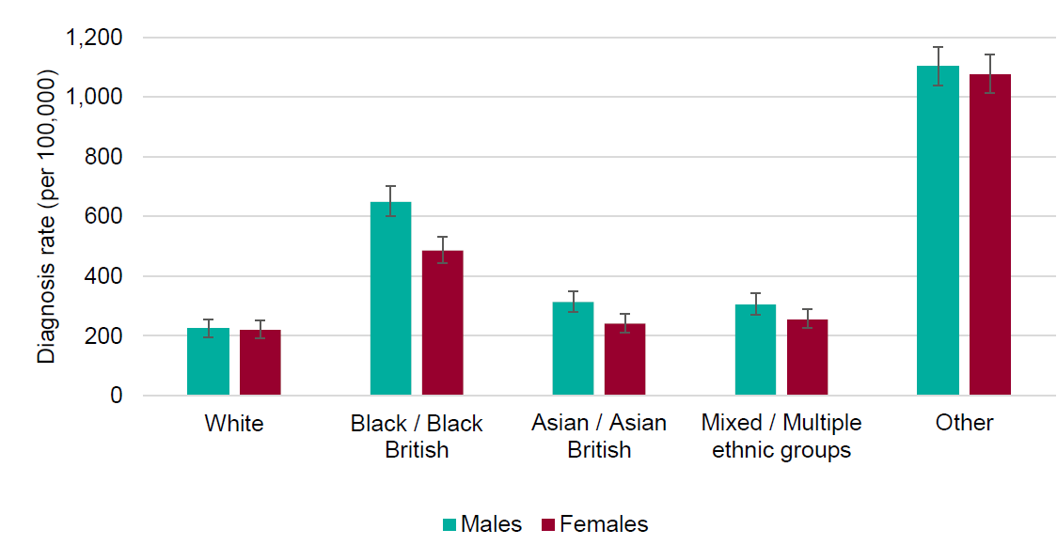
Source: Public Health England Second Generation Surveillance System.

￼
Figure 2: Age standardised mortality rates in laboratory confirmed COVID-19 cases by ethnicity and sex, as of 13 May, England. System.
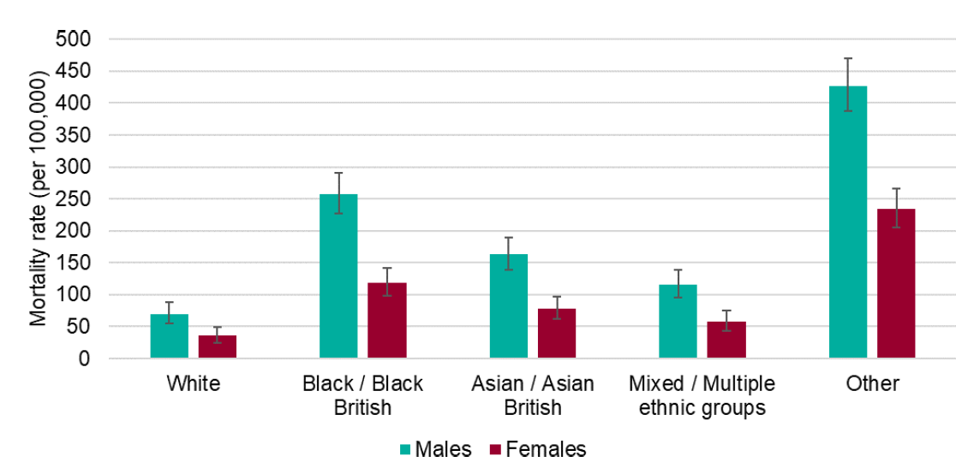
Source: Public Health England: COVID-19 Specific Mortality Surveillance

The worse outcomes for people from BAME communities are partly explained by the differences in age, sex, and the deprivation levels where people live. But even accounted for these factors, people of Bangladeshi ethnicity had around twice the risk of death compared with people of White British ethnicity. And people of Chinese, Indian, Pakistani, Other Asian, Black Caribbean and Other Black ethnicity had between 10% and 50% higher risk of death.

Other factors are therefore likely to have had a role, including occupation, other conditions that affect health such as obesity and high blood pressure, and related social and economic factors such as income and housing conditions.

Taking the nursing profession as an example, nationally, a total of 10,841 COVID-19 cases were identified in nurses, midwives and nursing associates registered with the Nursing and Midwifery Council. Among those who are registered, this represents 4% of Asian ethnic groups, 3.1% of Other ethnic groups, 1.7% of White ethnic groups and 1.5% of both Black and Mixed ethnic groups. This shows a clear inequality among Asian staff and staff from ‘other’ ethnic groups and demonstrates how membership of a specific occupational group can increase risk. The chart below shows the data:

Figure 3: Proportion of registered nurses, midwives and nursing associates with laboratory confirmed COVID-19 by ethnic group, as of 18 May 2020, England.
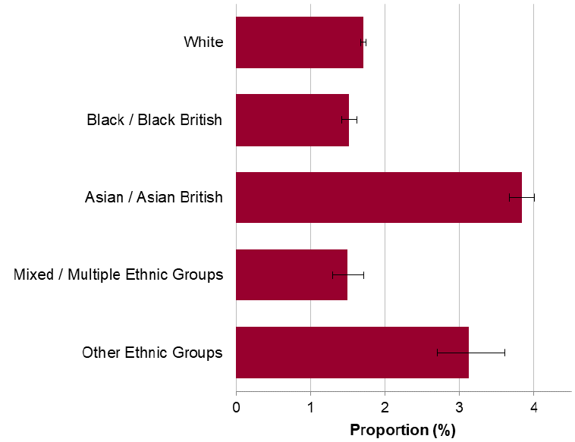
Source: NMC register and Public Health England Second Generation Surveillance System.

Similarly, occupations known to employ a significant proportion of BAME workers experienced significantly higher death rates from COVID-19. These included men working as security guards, taxi drivers and chauffeurs, bus and coach drivers, chefs, sales and retail assistants, lower skilled workers in construction and processing plants, and men and women working in social care.

Among deaths with COVID-19 mentioned on the death certificate, a higher percentage also mention an additional medical condition such as diabetes, diseases due to raised blood pressure, and chronic kidney disease compared with deaths that don’t involved COVID-19. And these differences varied by ethnicity. For example, for deaths involving COVID-19, diabetes was mentioned on 21% of death certificates overall, but on over 40% of death certificates for people from Asian and Black ethnic groups.

This is driven by the fact that people from BAME communities have higher rates of diabetes that people who are White British [ref National Diabetes Audit]. Similarly, people of Bangladeshi and Pakistani backgrounds have higher rates of cardiovascular disease than people from White British ethnicity, and people of Black Caribbean and Black African ethnicity have higher rates of hypertension compared with other ethnic groups.

Obesity also increases people’s risk of developing diabetes, heart disease and hypertension, and is associated with worse outcomes from COVID-19. The prevalence of obesity varies widely by ethnic group and is likely to be further exacerbating health inequalities in some BAME communities. The latest national data on prevalence of obesity shows that adults from White British and Black ethnic groups have significantly higher prevalence (63.3% and 73.6% respectively) than the national average (62%); prevalence in all other ethnic groups is significantly lower.

There is therefore no single reason why people in BAME groups have been disproportionately impacted by COVID-19. Instead, it is the result of a whole range of factors including housing, overcrowding, geographical deprivation, language, barriers to accessing services, occupation and comorbidities.

As summarised in the Public Health England report on disparities:
“The relationship between ethnicity and health is complex and likely to be the result of a combination of factors. Firstly, people of BAME communities are likely to be at increased risk of acquiring the infection. This is because BAME people are more likely to live in urban areas, in overcrowded households, in deprived areas, and have jobs that expose them to higher risk.

People of BAME groups are also more likely than people of White British ethnicity to be born abroad, which means they may face additional barriers in accessing services that are created by, for example, cultural and language differences.
Secondly, people of BAME communities are also likely to be at increased risk of poorer outcomes once they acquire the infection. For example, some co-morbidities which increase the risk of poorer outcomes from COVID-19 are more common among certain ethnic groups”

The implications for Oxfordshire

In Oxfordshire in 2011, 16% of the population were from minority ethnic groups, although this varies across the county with the majority people from ethnic minority groups based in Oxford and Banbury.

The map below shows the out of term time (i.e. excluding students) non-white British population as % of all residents but it cannot substitute for local knowledge of the fine detail.

It is impossible to generalise about the behaviour and preferences of individuals from crude data about ethnicity. There will be huge differences for example in the occupations, education, attitudes, linguistic ability and opportunities between, say, first and third generation migrant families. The data also tell us nothing of the qualifications, expectations and wealth of the individuals concerned, all of which are likely to vary widely. We should bear in mind when developing services that we are dealing with individuals as well as communities. One size does not fit all.

Figure 4: The proportions of BAME communities in Oxfordshire
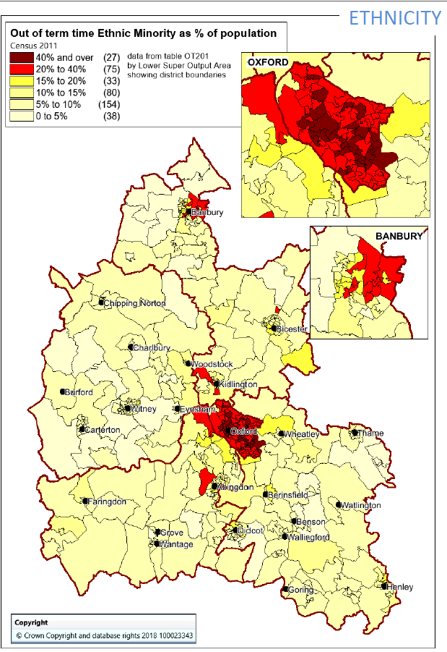

What is already being done and what services are currently available?

As evidence of COVID-19’s effects on BAME communities became apparent, a comprehensive response has been mounted at national and local levels.

A great deal of public information has been made available on the impact of COVID-19 on BAME communities through Oxfordshire County Council and NHS news feeds. Support services have been established for frontline workers in health and social care, along with a collection of resources, tips and ideas to support staff mental health and wellbeing. Furthermore, specific guidance for BAME employees has been issued for various occupational groups such as people working in nursing and residential homes, schools, and hospitals.

Similarly, the setting up and siting of local testing facilities has taken into account the local pattern of disease ‘hot spots’ which includes a consideration of BAME communities. In addition, plans for ‘shielding’ of at-risk groups, including BAME workers are in place.

Oxford University Hospital’s NHS Foundation Trust Case Study:

In April 2020, as evidence began to emerge that BAME staff were being disproportionately impacted by Covid-19, the Trust engaged with its staff and other stakeholders to understand some of the reasons behind the disparities and put in place measures to mitigate them.

Feedback from BAME staff was collated from various sources including the BAME staff network, Trade Unions, Chaplaincy, local community groups, and Occupational Health. Feedback was also received from specific engagement and listening events, such as those by the Freedom to Speak Up Guardians. This feedback was collated and analysed alongside other available data sources, such as Covid-related absence data from First Care.

Trust data on the impact of Covid-19 mirrored what was being seen nationally with an increased proportion of BAME staff taking sickness absence due to Covid-19, as compared with white staff.

There were cultural differences when it came to the adherence to safety measures. There were examples where overseas staff had received differing safety advice from friends and family members in their country of origin, resulting in confusion for those staff members.

Feedback also reflected an indirect impact of Covid-19 where measures to reduce social contact left people feeling isolated, impacting their wellbeing. This was particularly true for overseas staff and staff belonging to cultures where social gathering is a fundamental aspect of their life.

BAME staff experienced barriers in accessing health and wellbeing support. This was largely influenced by cultural factors, with mental health being heavily stigmatised in some cultures resulting in a reluctance to access support.

What did the Trust do to address the issues?

In order to address the impact of Covid-19, the Trust undertook a number of actions such as:

  - Inclusion of BAME background as a potential risk factor within the Covid-19 risk assessment process to ensure that the needs of BAME staff were adequately considered.
  - Guidance was produced by Occupational Health to support managers with undertaking the assessment. Support was also provided to managers by HR teams to embed these effectively
  - Identifying BAME staff to take on the Wellbeing Lead role so that they could use their lived experience to increase access to wellbeing support for BAME colleagues
  - Holding workshops with Wellbeing Leads to help them understand the potential barriers for BAME staff in accessing wellbeing support
  - Collating and producing wellbeing resources in a number of languages to increase accessibility of those resources. These resources were included in a comprehensive ‘online guide to health and wellness’ which brought together a number of resources into one directory enabling greater accessibility.
  - Initiating a quality improvement project within the Trust’s ‘Here for Health’ promotion service to improve awareness, access, and engagement for BAME staff and their families.
- Through working with Oxford Hospitals Charity, the Trust funded the appointment of a BAME Health and Wellbeing Lead. The role builds on work already undertaken, with an additonal focus on ensuring effective Covid-19 risk assessments are taking place, and supporting the Trust to develop a culturally sensitive health and wellbeing offer.

What do we need to do in the next 12 months?

COVID-19 has shed more light on what we know about the inequalities facing BAME communities and how social, and economic factors affect health. Over the coming year we need to work with BAME communities in Oxfordshire to understand how they have been specifically impacted by COVID-19.

By listening to our local BAME communities, we hope to identify ways that we can help build healthier places and through working every more closely with partners across Oxfordshire, emerge from COVID-19 with narrower inequalities and a healthier population.

3. Community Assets Based Working

Our intentions for 2020

The biggest influences on our health lie not in our hospitals and GP surgeries, but in our communities, our homes, and our workplace. No single aspect of people’s lives determines their health and wellbeing but factors as varied as our education and employment status, transport options, quality of housing and access to green space account for as much as 90% of people’s health.

Oxfordshire County Council’s Corporate Plan 2021 – 2024 aims to support “Thriving communities for everyone in Oxfordshire”. This includes a strong focus trying to ensure that where people live supports healthy and active lives, and encourages community run initiatives – this approach is known as “Healthy Place Shaping”. Healthy Place Shaping aims to create a built environment in our communities which enables healthy living and which increases access to and the sustainability of community assets – the features that can define a community. Assets might include a park or community centre, or a coffee morning or activity group.

Together, these assets can support people experiencing food poverty, help people exercise, and offer companionship for the lonely. They can support people to live healthier and happier lives, and help to narrow inequalities.

At the start of 2020, there were already some great examples in Oxfordshire of how communities have come together to improve the lives of everyone in the area. For example, in Barton in Oxford a 3-year part-time Community Health Development Officer – funded by the developer Grosvenor – has been recruited to support residents and local groups plan and deliver sustainable health and wellbeing activities to help in reducing local inequalities. The Barton Healthy New Town Delivery Group continue to meet regularly with a range of local organisations including Grosvenor development, Oxford City and Oxford County Councils, and the Oxfordshire Clinical Commissioning Group.

One focus for community led initiatives is ensuring access to healthy food. Oxfordshire are developing a “whole systems approach” to healthy weight with different partner organisations. One of the aims of the approach is to create Sustainable Food Places in Oxfordshire.

The Sustainable Food Place award recognises and celebrates the success of places taking a joined up, holistic approach to food. This means working across the food system to reduce waste identify sustainable ways of ensuring that every has access to healthy food. Oxfordshire aims to achieve Bronze Award by the end of March 2022 and Gold Award by 2026. Oxfordshire County Council contributed to the funding of Good Food Oxford (GFO) to work across the county to deliver on this agenda. To do this, GFO leads an active food partnership, committed to achieving positive change on a range of key food issues including food poverty, diet related ill health, and access to affordable healthy food. They have, for example, supported the development of the Community Food Services Network, which includes community larders, fridges and foodbanks. Data from GFO shows there was already a significant demand for foodbanks in Oxfordshire before 2020, giving out over 11,000 parcels in 2018/19.

Impact of COVID

The emergence of the COVID-19 pandemic changed the social landscape for our communities, forcing people to severely limit social interaction and reducing income for many families. The sudden need in local areas to ensure everyone was able to access food and medicine, along with providing an outlet to those who may be feeling isolated, galvanised local efforts into supporting neighbours, and community spirit blossomed under the circumstances. The resilience of the activities has been led by local communities, building on existing networks they had before the pandemic and in some cases creating new ones. Local knowledge has allowed local communities to define priorities that are relevant to their local area. This has ranged from a social media group for a street, to a formal effort from a parish council.

Volunteering and partnerships
Many organisations came together to support the local volunteering efforts, and in Oxfordshire this was strongly supported by Oxfordshire All In, a government grant funded local platform. This allowed communities to share ideas and initiatives and learn from each other as well as provide an introduction to volunteer and community services.

One significant challenge of COVID-19 was people’s ability to access food. Volunteer-led services felt pressure from increased demand, but had a reduction in available volunteers, many of whom were older people needing to self-isolate. A survey undertaken by GFO in May showed demand for food access services, such as food banks, community larders and community fridges, increased three-fold (up to 5500 users). 89% of respondents cited financial difficulties as the most common reason for accessing services, and 58% of services reported significant increases in usage from families with children.

In response, GFO expanded and updated their existing ‘Food Access Services’ map for Oxford to cover all Oxfordshire districts. OCC has also worked with GFO to understand the capacity and pressures of local community food services including food banks and community larders. This led to the establishment of district level local networks and a grant scheme (funded by DEFRA) for community providers and advice services. In conjunction with a scheme to support individuals, this funding is distributing a total of £500,000 of support for food during the autumn months. Further schemes continue to be developed as more funding becomes available.
Additionally, there has been a focus on ensuring children are able to access healthy food all year round, not just in term time. Play:Full is a ‘Brighter Futures’ initiative funded by Cherwell District Council and Sanctuary Housing to tackle holiday hunger in areas of disadvantage by offering food, mainly provided by the food bank, and activities during the school holidays. This model is now being piloted in Littlemore and if successful could be rolled out more widely across the county.

Engaging with and repurposing existing local assets
The importance of place-based working was emphasised by the pandemic when the lockdown forced all of us to stay local, creating the opportunity for some residents to rediscover the assets in their neighbourhood.

For some residents the lockdown created the opportunity to become more active, as they made the most of local walking routes, parks and the countryside to take their daily walk or cycle or gain the mental benefits of time in the natural environment. In Bicester, use of its circular health routes increased by up to 100% during the Spring lockdown and national surveys reported that 41% of adults reported visiting urban green spaces, such as parks and playing fields in April. However, the pandemic also shone a spotlight on the inequalities embedded in our community with a quarter of adults (26%) reporting that they had not visited any green and natural space in April and Sport England’s Active Lives survey highlighting that inactivity had increased in those groups who already find it harder than most to be active, with disabled people, people with health conditions, and younger people all struggling.

There are different types of community spaces available in each locality, ranging from village halls and pubs, to village run shops to outdoor spaces. Community First Oxfordshire is an organisation that supports the running of any community space, and a good example of the infrastructure available to help the community through this difficult period. Community First Oxfordshire have noticed many village halls and pubs have been badly impacted by the pandemic, particularly in relation to restrictions on social gatherings affecting their income stream.

However, community run shops have shown themselves to be extremely valuable community hubs. In the first lockdown, shop volunteers teamed up with other community organisations such as parish councils, to deliver food boxes to the most vulnerable. Many of the usual shop volunteers were over 70 and had to self- isolate, but new volunteers came forward as many people were furloughed or began working from home. Unlike most other places, some community shops have made financial surpluses this year; a first for many of them.

One great example is the Brightwell Cum Sotwell Village Stores. In discussion with Community First Oxfordshire, Celia Collette, representing the Village Stores, reported,
“not only had our volunteers provided about 30 deliveries of food boxes to local people every week in the first lockdown, we also supported our local small traders by stocking more local produce than ever before”.

Although the food box delivery has stopped, people can still order a box of food and pick it up outside the shop. Those who need it can still have a delivery. The shop keeps in touch with their volunteers with a regular email update to let them know they are not forgotten and that it is hoped they will return when the pandemic has subsided. Celia said “If I had to pay all the additional hours that volunteers put in, it wouldn’t be a viable business!” The worth of community shops cannot be measured in monetary terms but instead they are rich in local support. Community shops are great community assets!

Opportunities going forward

Looking forward, Oxfordshire aims to maintain the benefits of the resilient community networks and support them with continued improvements in the built environment, particularly those residents and communities hardest hit by COVID-19. Healthy place shaping can be used to create resilient 20 minute neighbourhoods which promote social interaction, making it possible to walk and cycle to local services within 20 minutes.

The development of local food networks and local services has contributed to closer community working across much of the county. Due to COVID, community mutual aid has held a much higher profile, with engagement from a broader group of people. Additionally, the population’s awareness and support for their local assets and services, instead of traveling further afield, can help communities become stronger still. This will be supported by OCC’s 2020 Climate Action Framework, which has the plans to make itself a carbon neutral organisation by 2030, and to enable Oxfordshire to become zero-carbon by 2050. One of the framework’s action is to “support both the consumption of healthy and sustainable food, and reduce food waste throughout the supply chain”. This will link with the whole system approach for healthy weight, and continue to bring all partners together to work towards this goal.

The long-term benefits of this increase in community engagement and support will take a while to be fully realised. Our aim is to ensure the resilience built into communities can allow local areas to thrive, both in wellbeing and economically.

4. Conclusion

This year’s report has showcased the disproportionate impact of COVID amongst certain communities like BAME group. It also highlights some of the excellent work we have done as partners coming together across the Oxfordshire system. At this point, we are uncertain as to how COVID pandemic will emerge in future years. It is likely however, we will be living with the COVID virus over the next decade. Thanks to emergence of the successful vaccination programme means that we have managed to curtail the direct impact of the COVID virus. However, some of adverse indirect impact of the COVID virus are only starting to emerge. We know the delayed health services, workforce shortages and the lack of preventative services is likely to exacerbate the long term conditions such as CVD and cancer, and place huge demands on our already strained health and care system. We, as a nation, also likely to see some of significant economical impact, particularly impacting our most disadvantaged communities.

Despite all this, this report has highlighted what we can achieve as a system coming together working as a partnership across organisational and professional silos. We should not lose this way of working in the post COVID era. We must retain the relationships and structures formed and use the same momentum and urgency to tackle the above mentioned indirect impacts of COVID. We have to do all this with our communities and create a healthy place where positive health and wellbeing outcomes are the norm.

https://www.oxfordshire.gov.uk/residents/social-and-health-care/public-health-and-wellbeing/public-health-annual-report
Our vision: Thriving communities for everyone in Oxfordshire | Oxfordshire County Council
https://www.gov.uk/government/publications/covid-19-review-of-disparities-in-risks-and-outcomes
https://www.health.org.uk/news-and-comment/charts-and-infographics/same-pandemic-unequal-impacts
http://insight.oxfordshire.gov.uk/cms/unemployment-claimants-october-2020
https://obr.uk/efo/economic-and-fiscal-outlook-november-2020/
https://www.trusselltrust.org/2020/11/12/2600-food-parcels-provided-for-children-every-day-in-first-six-months-of-the-pandemic/ https://www.trusselltrust.org/wp-content/uploads/sites/2/2020/11/Data-for-Public-Use_FINAL-1.xlsx
https://www.gov.uk/government/publications/covid-19-review-of-disparities-in-risks-and-outcomes
https://www.gov.uk/government/publications/covid-19-review-of-disparities-in-risks-and-outcomes
https://insight.oxfordshire.gov.uk/cms/jsna-oxford-2020
Health lives for people in the UK
OCC corporate plan 2020 – 24 CorporatePlan2020 (oxfordshire.gov.uk)
Health inequalities: place-based approaches to reduce inequalities - GOV.UK (www.gov.uk)
Four ways we can build a more inclusive economy - RSA (thersa.org)
Sustainable Food Places Award | Sustainable Food Places
Oxfordshire Joint Strategic Needs Assessment 2020. Joint Strategic Needs Assessment | Oxfordshire Insight
Oxfordshire All In website : Oxfordshire All In
Report on Oxfordshire’s Community Food Services during COVID-19. Good Food Oxford, May 2020
Link to Food Access Services map ; Locations | Food Services in Oxfordshire (goodfoodoxford.org)
Coronavirus (COVID-19): Local authority Emergency Assistance Grant for Food and Essential Supplies - GOV.UK (www.gov.uk)
“Brighter Futures”, Cherwell District Council https://www.cherwell.gov.uk/info/118/communities/483/brighter-futures-in-banbury/5
The People and Nature Survey for England September 2020
Active Lives Adult Survey October 2020
https://www.communityfirstoxon.org/
https://www.tcpa.org.uk/the-20-minute-neighbourhood
Oxfordshire County Council Climate Action Framework 2020 https://www.oxfordshire.gov.uk/sites/default/files/file/about-council/OCC_Climate_Action_Framework-August2020.pdf

