Gender Pay Gap Report 2023

Background

- The Equality Act 2010 (Specific Duties and Public Authorities) Regulations 2017 stipulate that all businesses, public sector and third sector organisations with over 250 employees must publicly report on average pay differences between their male and female employees. The Regulations require employers to publish their:

• Mean gender pay gap in hourly pay

• Median gender pay gap in hourly pay

• Mean bonus gender pay gap

• Median bonus gender pay gap

• Proportion of males and females receiving a bonus payment, and

• Proportion of males and females in each pay quartile.

- As a public sector body, we are required to publish this pay gap information within 12 months, taking the “snapshot date” of 31 March 2023

- Our calculations follow the legislative requirements as set out in the Equality Act 2010 (Specific Duties & Public Authorities) Regulations 2017. All staff who were deemed to be relevant employees at 31 March 2023 are included.

- This information will be published on the Oxfordshire County Council (OCC) website for a minimum of 3 years and published on the government website (www.gov.uk) by 31 March 2024.

Equal pay and gender pay gap

- The purpose of gender pay gap reporting is to achieve greater gender equality in terms of pay across the UK and increase pay transparency. This differs from equal pay which deals with differences between men and women who carry out the same roles.

Details within this report

- Using a snapshot of employees’ pay as at 31 March 2023, only 3 of the 6 calculations detailed above were made due to no bonus payments being paid at Oxfordshire County Council. The 3 calculations are as follows:

1. Mean gender pay gap
2. Median gender pay gap
3. The proportion of men and women divided into four quartile pay bands

Information required for publication

Relevant employee

- An employee who was on full pay (not reduced to parental leave pay or sick pay) at the point of the data snapshot as at 31 March 2023.

Mean gender pay gap

- The mean is defined as the average of the figures and is calculated by adding up all the figures and dividing by the number there are.

Median gender pay gap

- The median is defined as the salary that lies at the midpoint and is calculated by ordering all salaries from highest to lowest and the median is the central figure.

Quartile pay bands

- The quartile information is calculated by listing all salaries from highest to lowest and then splitting that information into four equal quarters to determine the percentage of male/female employees in each quartile.

Workforce profile

11. On 31 March 2023, OCC had 5,405 relevant employees of which 34.1% (1,841 employees) were men and 65.9% (3,564 employees) were women.

Gender pay gap as at 31 March 2023

Mean: percentage difference and average hourly rate of pay

Gap: 1.2% £0.22p per hour

£18.53 £18.31

12. The mean difference recorded at Oxfordshire County Council has decreased from 2.3% in March 2022 (£0.41p per hour) and is considerably less than the national mean pay gap which was reported at 14.9% in 2022. (Gender pay gap in the UK: 2022: Office of National Statistics).

13. As at 31 March 2023 the mean hourly rate for men was £18.53 per hour and for women it was £18.31 per hour. This means men earned an average of 22 pence per hour more than women, which equates to a mean difference of 1.2%. The figures for 2020, 2021, 2022 and 2023 are as follows, showing a slightly steeper increase for females of £2.13 per hour over four years than the increase for males of £1.82 per hour.

Median percentage difference and hourly rate of pay

Gap: -4.4%

£16.32 £17.04

14. As at 31 March 2022 the median hourly rate of pay for men (£16.32) was less than as for women (£17.04). This gives a median gender pay gap of -4.4%, which is considerably less than the national public sector median pay gap which is 14.9% (Annual Survey of Hours and Earnings, Office for National Statistics). This represents a national decrease from 15.1% in 2021.

15. This represents a change of -4.4% from 2022 where the median gender pay gap was 0%, this could be due to the changes in the workforce as there has been an increase of 296 female employees and only 93 males since 2022.

16. The figures for 2020, 2021, 2022, and 2023 are as follows, showing a steeper increase for females of £2.13 per hour over four years than the increase for males of £1.21 per hour.

Proportion of men and women receiving bonuses

- OCC does not operate any performance related pay or bonus schemes and therefore has no bonus gender pay gap.

Pay quartiles

- OCC employed 5,405 relevant employees1 as at 31 March 2023 which equates to 1,351 employees per pay quartile. The gender split per quartile as at 31 March 2023 is detailed below and serves as a useful benchmark to determine progression through the pay scales.

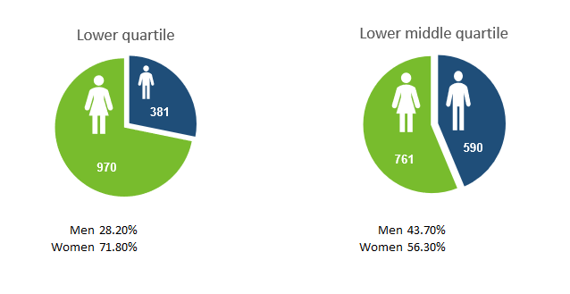
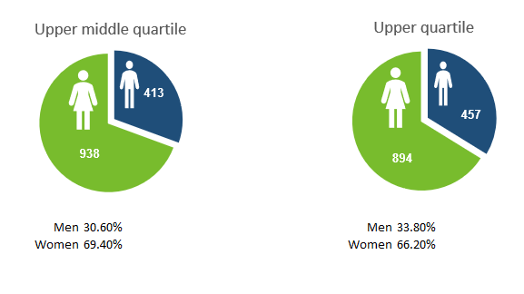

- The hourly rates that represent each quartile are as follows:

• Upper - relates to the hourly rates of £21.49 and above
• Upper middle - relates to the hourly rates of £17.04 - £21.49
• Lower middle - relates to the hourly rates of £12.98 - £17.04
• Lower - relates to the hourly rates up to £12.98

- The proportion of males to females in each quartile has shifted significantly since 2022 which will partly be due to the significant increase of females versus males entering into the workforce in 2023 (see above).

- The lower quartile has seen a 2.4% increase of females since 2022, with 71.8% of the lower quartile being female – this is not reflective of the total workforce where 65.9% of the total workforce are female.

- There has been a 3.7% increase of males in the lower middle quartile since 2022 and a decrease total 4.5% of males in the top two quartiles.

- In the lower quartile the roles occupied are mainly cleaning, administration, school crossing patrol, catering and customer service. For some of these functions there is no obvious career progression route to higher earnings levels. However, the council continues to promote opportunities for staff to undertake apprenticeships whilst in employment with the Council.

- At senior management level, 50% of the Extended Leadership Team (directors, deputy directors and assistant directors) are women and 50% are men. Although this is an even balance, it does not reflect the two thirds of the total workforce who are women.

Commitment

- We are committed to the principles of equality, diversity, fairness and inclusion and our approach to people management should not put any group at a disadvantage. Regardless of identity or background, everyone deserves to be able to develop their skills and talents to meet their full potential, work in a safe, supportive and inclusive environment, be fairly rewarded and recognised for the work they do and have the opportunity to have their say on matters that affect them. We are also committed to achieving a diverse workforce that fully reflects our community.

- We will continue to explore our inclusion initiatives, particularly where there are any barriers for women to progress into higher paid roles, or roles where they are under-represented.

- Flexible, agile working and family friendly policies will assist Oxfordshire County Council to attract and retain staff in a competitive job market and in a geographical area with low unemployment.

Summary

- The gender pay gap within OCC is small, however while we understand that publishing the data will not in itself remove the gap, continuing to do so is the first step towards that aim and we are committed to learning from best practice as part of our journey. The gender pay gap data will be analysed on an annual basis, a comparison of figures will be completed year on year. We will ensure that job grades continue to be determined through objective analysis and job evaluation to maintain the integrity of the pay and grading system.

October 2023

