PSED

Personal, social and emotional development (PSED) is possibly the most important of the prime areas of learning in the Early Years Foundation Stage (EYFS) for the under-threes. This is the age at which children learn the skills they need to become actively involved in the world around them.

Personal, social and emotional development (PSED) supports children to learn to get on with others and make friends, understand and talk about feelings, learn about 'right' and 'wrong', develop independence, and ultimately feel good about themselves. So, it has three strands of learning:
- making relationships
- managing feelings and behaviour
- self-confidence and self-awareness
Making relationships
Relationships lie at the heart of all human experience and interaction, and it is vitally important that young children are helped to learn the social skills needed to interact successfully with other people and to form good relationships.

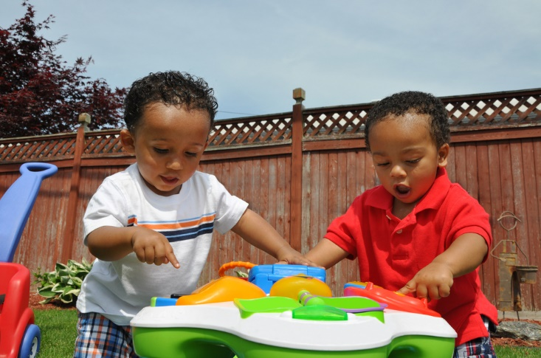

Children who have the skills to interact well with other people and form positive relationships can tap into a huge resource to support their learning.

Young children also need lots of opportunities and encouragement to begin to look at the world from the perspective of others and to develop empathy – which is not always easy for the under-threes to understand!

Helping children to manage feelings and behaviour

Young babies and children need support from others – parents, carers and family members – to regulate their feelings. This support, consistently given, helps them to understand basic emotions, begin to control their impulses and learn how to manage and display their feelings appropriately.

Children need to feel comfortable, both emotionally and physically, to allow them to learn effectively. Helping children to learn how to regulate and manage their feelings is therefore a vital stepping stone for success in learning and in life.

Self-confidence and self-awareness

Supporting young children to grow in self-confidence and self-awareness involves providing opportunities for children to:

• develop a positive sense of themselves and others

During their early years, young children build their understanding of themselves as individuals, which increases their confidence to engage with the people, objects and experiences in the world around them.

• have confidence in their own abilities.

As children grow in self-confidence and self-awareness, they extend their horizons and begin to see that what they do can make a difference. This ability to proactively engage with the world underpins all other aspects of a young child’s learning.

Promoting Social-Emotional Development in Your Child

1.Love your child and show your affection for them. Hug, cuddle, read, and talk with them throughout the day.

2.Encourage your child to try new things. ...

3.Give your child opportunities to play with other children their age. ...

4.Show your feelings. ...

5.Establish daily routines. ...

6.Acknowledge your child's feelings.

Personal Social and Emotional development underpins all other learning. To be a sociable integrated member of society children need to develop and manage their own and other's feelings and develop their ability to see things from another person's point of view. Supporting your child to develop emotional resilience is key to them being able to focus and learn, thus giving them the best chance to succeed in life.

Babies

Provide praise and encouragement to build self-confidence and self-esteem. Give babies plenty of time to try things for themselves, to build their independence, to gain a sense of achievement and to develop self-awareness.

Mirrors, either fixed to the walls, placed on the floor or hand-held, can engage babies’ interest for long periods of time as they reflect on their own identity.
Make sure there is a balance between focused attention from adults and time to themselves.

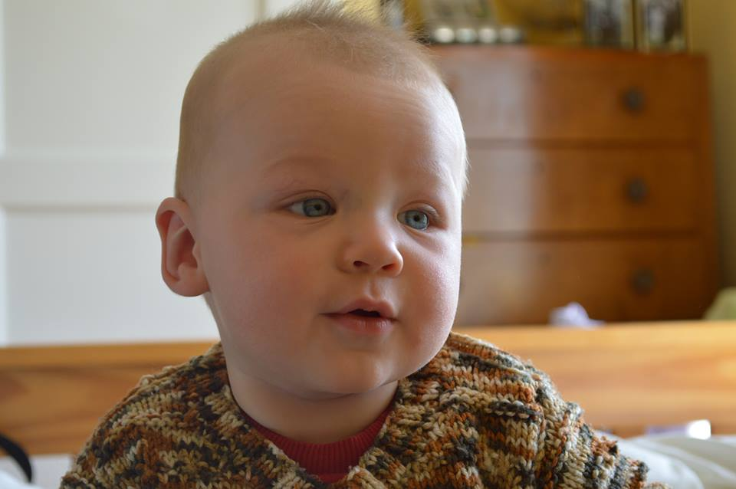

Physical care-giving also provides time to develop emotional attachment and interaction with a parent, caregiver or key person.

During the day, make sure there are times for one-to-one interaction between adults and children, but also plan times when babies can play together in a larger group, watching and learning from one another.

Toddlers

Use your toddlers’ interests to share good learning opportunities and enjoy playing together. Sharing time together will also show you what personality your toddler has, and their preferred way of learning.

Providing open-ended resources that can be used in a wide variety of ways will
encourage toddlers to try out their ideas and build their sense of achievement. These resources could include boxes, tubes, blocks, bags, small baskets, rings, wooden pegs, short lengths of chain, pine cones, pebbles, shells, fabrics, paper and card.
Children of this age are beginning to develop a wide range of physical skills: help boost their independence and self-esteem by giving them time to manage complex tasks such as putting on a pair of socks or shoes; or fastening a coat. This may take an inordinate length of time and may not always be entirely successful; but remember that it is the learning process that is important, not the end result!

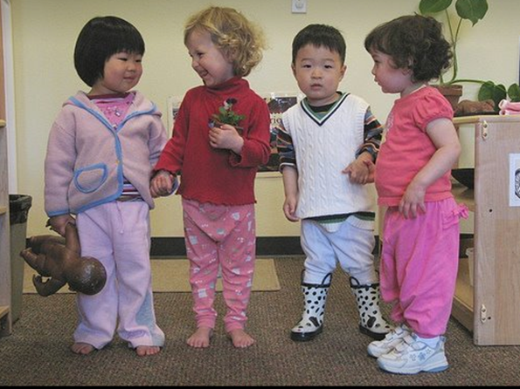

•Play games; take turns and play by the rules.

•Share things; share out snacks or toys or bricks and encourage little ones to do so as well.

•Go to local places of interest, history museums, libraries or galleries.

•Look at programmes from theatre or festivals visits. Or pick up leaflets from places of interest and local history museums. Look through the information/booklets together when you get home.

•Take photos when out and about and look back at the photos together. Recall the day, where you were, who was with you, what happened etc.

•Listen to what your child wants to talk about, especially if they are anxious or worried about something. It may seem tiny to us, but a little problem can escalate.

•Encourage lots of questions, talk, and exploring when out and about.

Play ideas for young children 6 -18 months https://theimaginationtree.com/baby-play-ideas-and-activities-6-18/

